Introduction

**1.1 Backgroun**

Many people love trying different things, different food, different drinks, but not all these adventures have a good end.

**1.2 Problem**

How can people find a good place to try new food for example and after eating become satisfied of his adventure?

This project aims to find the best Egyptian restaurant in Now York that has good rating, likes and tips.

Data

I will use :

1. <https://cocl.us/new_york_dataset>: to get the data.
2. Foursquare API: to get all the venues in each neighborhood. We can filter these venues to get only Egyptian restaurants.
3. GeoSpace data: to visualize the data

Analysis

By analyzing the data I found that their are only 3 Egyptian restaurants in New York as the following:

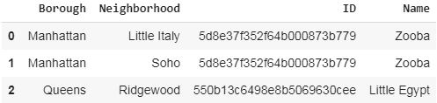

Then I added the stats of each restaurant and I get that:

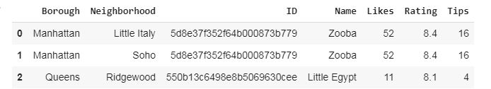

After that a added the location of each restaurant :

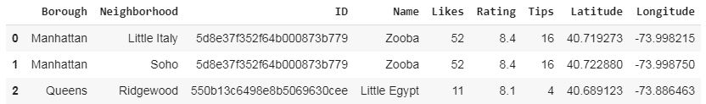

Finally I made a map for the restaurants :

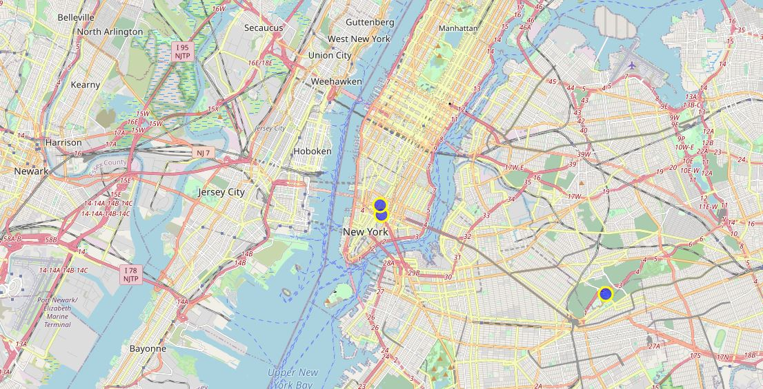

The blue circles are the restaurants.

**Observation**

After analyzing these data I found that the best restaurant according to the rating, likes and tips it was Zooba in Little Italy

**Conclusion**

The number of Egyptian restaurants in New York is very small. The best restaurant is Zooba in Little Italy then Zooba in Soho then the last one is Little Egypt in Queens.

***THANKS*** ***!***